Analyse Distinctive Features of Epistemology of Engineering Design

Science, Engineering, and Technology are often confused with each other. All three are closely related but mean different things. In this post, we have tried to bring out the differences between science, engineering, and technology.

“Science is the study of the natural world as it is; engineering is creating new tools, devices, and processes based on ***scientific***knowledge; technology is the sum total of all the ***engineered*** tools, devices and processes available.”

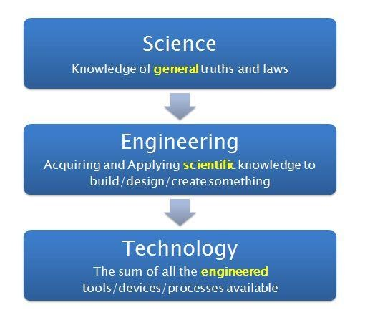

Now that we know the basic definitions and the overall comparison between the three, let’s move to a set of alternate differences between them. The differences below may seem redundant, and that’s because they are. They are all different ways of saying the same thing. Choose whichever appeals you the most:

1. Science is knowledge of the natural world put together, Engineering is creation based on the scientific knowledge put together, and Technology is the set of engineered creations put together.

2. Science comes from observation of the world, Engineering comes from acquiring and applying knowledge, and Technology comes from repeated application and approval of the engineered tools.

3. Science is about creating meaning of natural phenomenon, Engineering is about creating new devices, tools and processes, and Technology is about creating a collection of engineered and tested tools for the mankind.